JUDEA AND SAMARIA WEEK
Bachan & Yearim
Kol Ami
2018
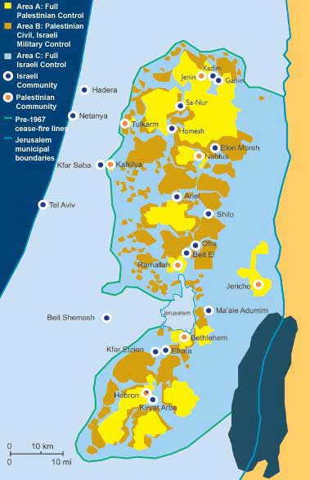

 | יום ג' 13.10 שומרון | יום ד 14.10 גוש עציון | יום ה' 15.10 חברון | יום ו 16.10 הר ברכה
09:00 | פדואל- הדרכה+ פעילות | נסיעה לגוש עציון | סיור בחברון | שיחה עם שיבי פרומן בתקוע **בעברית**
09:30
10:00 | מצפור יוסף- הדרכה | לוחמים לשלום + ארוחת צהריים
10:30 |  |  |  | נסיעה לנווה דניאל
11:00 | מפגש עם שומרונים **בעברית** |  |  | בראנצ' בנווה דניאל
11:30
12:00
12:30 | נסיעה לאיתמר |  |  | נסיעה להר ברכה
13:00 | מפגש עם לאה גולשמיט תושבת איתמר
13:30
14:00 |  |  | שיחה עם ישי פליישר- דובר הישוב היהודי בחברון | הגעה להר ברכה+התארגנות
14:30 | ארוחת צהריים
15:00
15:30 | נסיעה לשילה | נסיעה לקבר רחל
16:00 | שילה הקדומה |  | נסיעה למגדל עוז
16:30 |  | סיור עם זכויות אדם כחול לבן -קבר רחל | סיור במגדל עוז עם מורה דרך
17:00
17:30
18:00 | נסיעה לק. יערים | נסיעה לכפר עציון
18:30 |  | חיזיון אור קולי
19:00 | ארוחת ערב
19:30 |  | נסיעה לאפרת | ארוחת ערב
20:00 | שיעור של גבי- מה בין יו"ש לבנינו? | ארוחת ערב -קייטרינג
20:30 |  | מפגש עם תושב אפרת | מפגש עם ארגון שורשים- ג'ודור
21:00
22:00 | סיכום יום | סיכום יום | סיכום יום
לינה
 | יערים | אפרת | מגדל עוז

Thursday 15th

9:00-2:00 Tour in Hebron

2:00-3:30 Talk with Ishai Fleisher (spokesperson of Jewish Yishuv in Hebron)

3:40-4:00 Drive to Migdal Oz

4:15-6:30 Tour at Migdal Oz

6:30-7:30 Dinner

7:30-9:00 Meeting with Shoreshim-Gudur organization

9:00 Summary of the day

Wednesday 14th

10:00-3:30 Fighting for peace + lunch

3:30-4:30 Drive to Rachel’s tomb

4:30-6:00 Blue and white at Rachel’s tomb

6:00-6:30 Drive to Kfar Etzion

6:30-7:30 Museum Tour

7:30-8:00 Drive to Efrat

8:00-8:30 Catered dinner

8:30-10:00 Meeting with representative from Efrat

10:00 Summary of the day

Tuesday 13th

9:00-10:00 Pduel -Hadracha and activity

10:00-11:00 Mitzpor Yoseph- hadracha

11:00-12:30 Meeting with Samaritan (in Hebrew)

12:30-1:00 Drive to Itamar

1:00-2:30 Meeting with Lea Golshmidt

2:30-3:30 Lunch

3:30-4:00 Drive to Shiloh

4:00-6:00 Hadracha and movie in Shiloh

6:00-7:00 Drive to Kiriyat Yaarim

7:00-8:00 Dinner

8:00-10:00 Lecture by Gabi -“the difference between us and Judea and Samaria

10:00 Summary of the day

Friday 16th

9:00-10:30 Talk with Shivi Fruman in Tkoa (in Hebrew)

10:30-11:00 Drive to Neve Daniel

11:00-12:30 Brunch in Neve Daniel

12:30-2:00 Drive to Mount Bracha

2:00- Arriving at Mount Bracha & getting ready 4 Shabbat

1. JOSEPHS TOMB
Joseph's tomb is the second holiest site for Jews, Christians and Muslims and is located in Samaria. There is no archaeological evidence establishing Joseph's tomb. Josephs remains were carried from Egypt and were buried in a plot of land Jacob had bought. In 1996, Shechem was given over to Palestinian authority but Joseph's tomb was to remain in Jewish hands. However, in the 2000s, due to acts of terrorism, the tomb was given up to Palestinian Authority under fire.

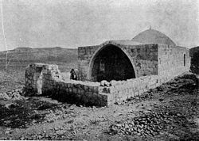

2. ‏MOUNT GRIZIM
Also known as "Har Brakha" is the name of a large mountain range south of the city of Nablus. The high mountain in the ridge is the biblical Mount Gerizim which is sacred to the Samaritan community.
‏About half of them lives in the "Loza" neighborhood on the western slopes of the Mountain, which also includes the site of "Passover sacrifice", the Samaritan Museum - Greizim and the cemetery of the community. ‏The Samaritan Temple was built on the mountain by Sanballat II in the 4th century BCE and was destroyed in 112 or 111 BCE by John Hyrcanus.
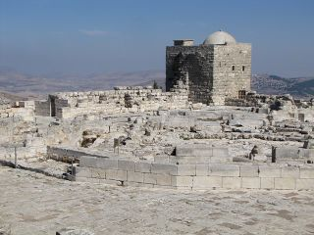

3. THE SAMERITANS
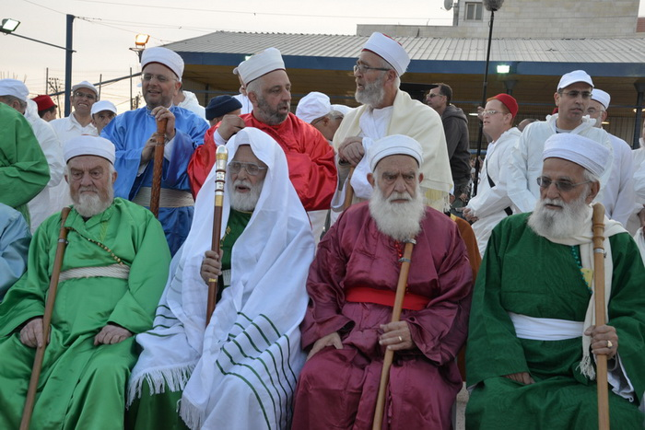
"Guardians/Keepers/Watchers (of the Torah)" are an ethnoreligious group of the Levant originating from the Israelites (or Hebrews) of the Ancient Near East. The Shomronim observe commandments (mitzvot) according to the Jewish holy and literary sources. The Samaritans only live in Israel particularly in mountain Gerizim and Holon. Their language is similar to ancient Hebrew, and their lifestyle is based on a unique version of the Torah. Throughout the history there has been religious controversies between the Shomronim and the Jewish people

3. ITAMAR- Lea Golshmidt
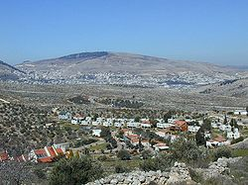
An Israeli settlement located in the Samarian Mountains. Under the Oslo Accords of 1993, Itamar was designated Area "C" under full Israeli civil and security control. The international community considers Israeli settlements in the West Bank illegal under international law, but the Israeli government disputes this.

4. ANCIENT SHILO
Shilo was an ancient city in Samaria mentioned in the Torah. Shiloh was the major Jewish worship centre before the first temple was built in Jerusalem. Shiloh was an assembly place for the people of Israel and a centre of worship. Shiloh is sacred to the three religions-Judaism, Christianity and Islam and pilgrims have come to visit the ruins for the past 3000 years. On the south east side of Shilo are ruins of Mosques, churches and synagogues.
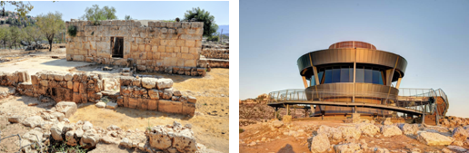

5. COMBATANTS FOR PEACE
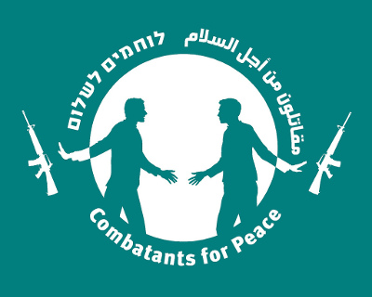
Is an Israeli-Palestinian Non-Government organization and egalitarian movement committed to non-violent action against the Israeli occupation and all forms of violence in Israel and the Palestinian territories. This movement began in 2006 by Palestinians and Israelis who had taken a role in violence and wanted to work together to promote a peaceful solution.

6. KFAR ETZION
Kfar Etzion is an Israeli settlement and religious kibbutz in the Judean Hills between Jerusalem and Hebron. It was established in 1927, depopulated in 1948 and then re-established in 1967. It was destroyed in the 1948 War of after a 2-day battle in which residents of the Jewish kibbutz and Haganah defended Kfar Etzion from Arab forces. The events are also known as "Kfar Etzion massacre" where 157 died in the battle of Gush Etzion.
In 1967 after Israel reoccupied the eare from the Jordanians, and the Israeli cabinet decided to re-establish the settlement.

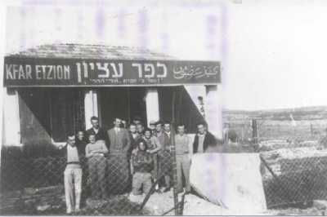

Rachel’s tomb is the site revered as the burial place of the matriarch Rachel. The tomb has been considered holy to Jews, Christians and Muslims for 2000 years. Located at the northern entrance of Bethlehem, It's built in the style of a traditional maqam. Although this site is considered unlikely to be the actual site of the grave it is by far the most recognized candidate. Today, Rachel’s tomb is used as a place of prayer to Jews that come through all the year, and especially at 11th of Heshvan which by tradition is the day Rachel died

7. RACHEL TOMB
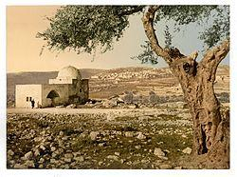

8. BLUE & WHITE HUMAN RIGHTS
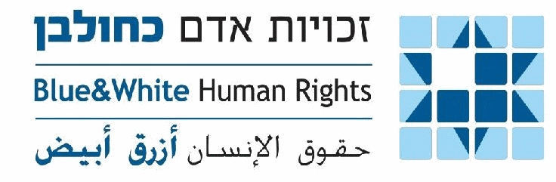
Created as a Zionistic ideal, to enable individuals to support Palestinian rights and dignity and strengthen Israel as a just and worthy society, They believe that security requirements and observing the human rights of all who come under Israeli rule- comes together.
Their goal is to solve real Palestinian problems on the ground through active and constructive interaction with Israeli authorities.

9. JEWISH SETTLEMENT IN HEBRON
In the spring of 1968, Rabbi Moshe Levinger together with a group Israelis, rented the main hotel in Hebron and then refused to leave. Defence minister Moshe Dayan ordered their evacuation but agreed to relocate them on a nearby military base on the eastern outskirts of Hebron which was to become the settlement Kiryat Arba. In 2012, the IDF called for the immediate removal of new settlements, because it was seen as provocation. In August 2016, Israel announced its intention to allow settlement building in the military compound of Plugat Hamitkanim in Hebron.

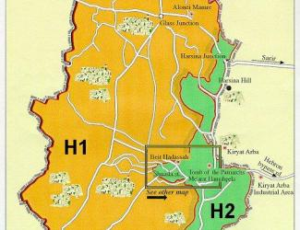

10. ROMANO HOUSE HEBRON
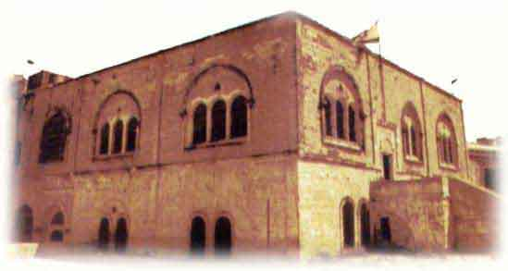
The Romano house is located in the centre of the old city of Hebron. It was built in 1876 by a rich merchant from Turkey Avraham Romano. The building was used as a Torah centre and was later established as a Yeshiva in 1901 with a dozen teachers and up to 60 students. In 1982, Israel authorities took over a Palestinian education office. The school was turned into a settlement.

11. HADASSAH HOUSE HEBRON
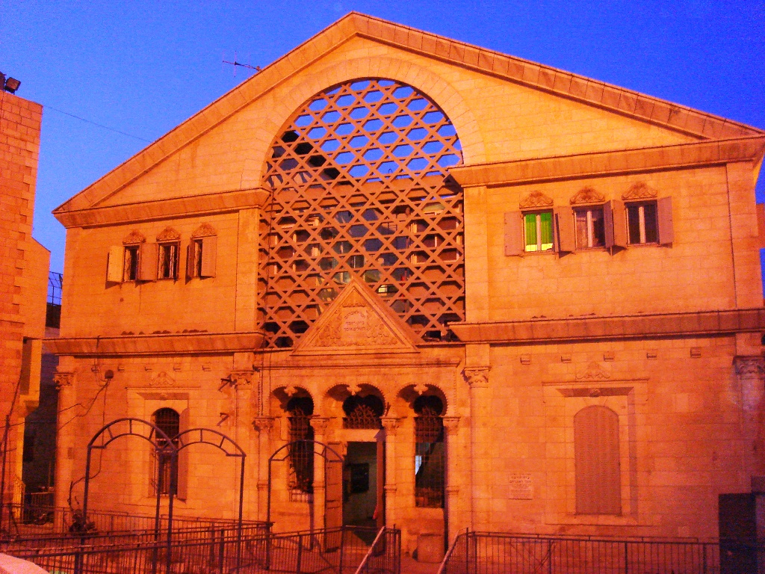
The Hadassah house was constructed in 1893 with donations from Jewish Baghdadi families and was the only modern facility in Hebron. In 1909, it was renamed after Hadassah Womens Zionist Organisation of America which took responsibility for the medical staff and provided free medical care to all. In 1929, the hospital was the site of some of the worst of the rioting that killed 67 Jewish residents. The clinic was looted and burned. Under Jordanian rule (1948 – 1967) all Jews were barred from the city the building converted into a school. Today, about 30 Jewish families live in these buildings.

12.PATRIARCH TOMB
A building in the west of Hebron which dates back over 2000 years. The monumental Herodian compound is believed to be the oldest continuously used intact prayer structure in the world, and is the oldest major building in the world that still fulfills its original function.
It is believed that the fore mothers and fathers are buried there including Abraham and Sarah, Isaac and Rivkah and Jacob and Leah. The only Matriarch missing is Rachel, who is said to be buried in Bethlehem.

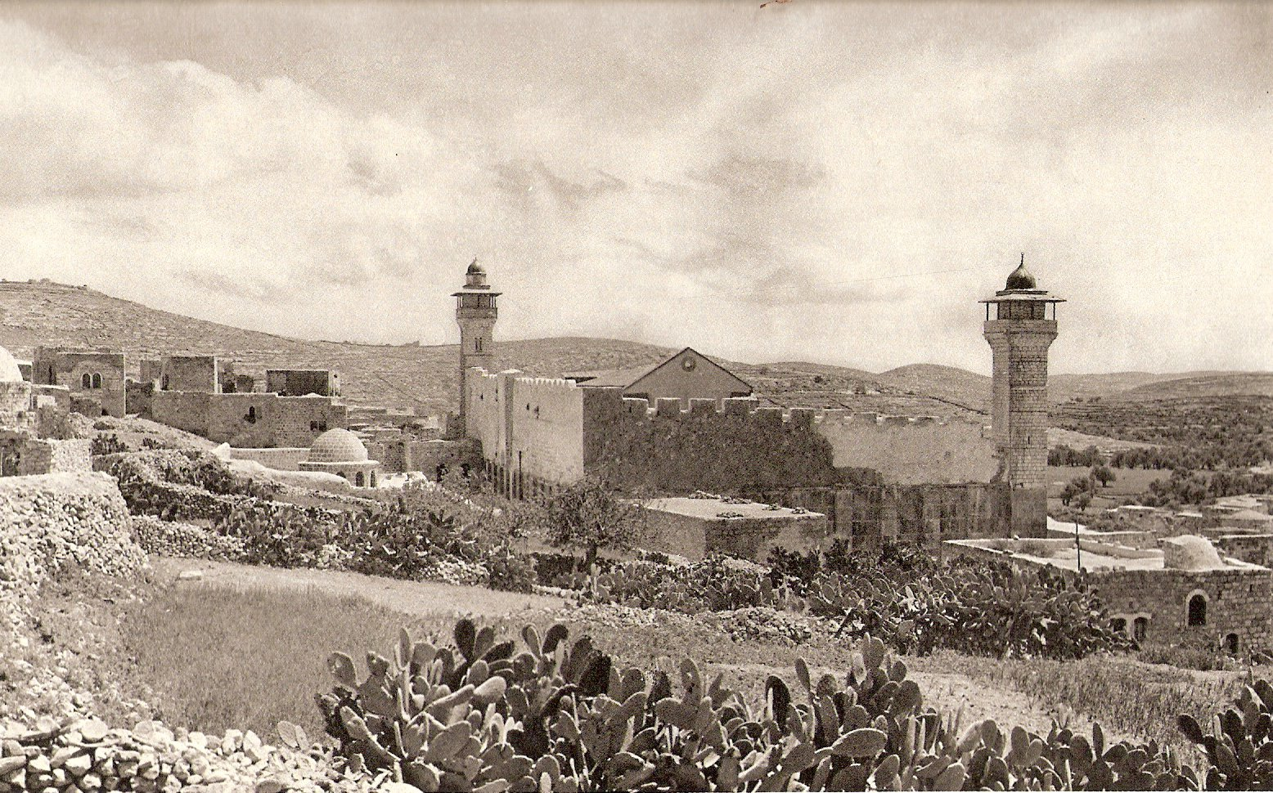

13. SHORASHIM ORGANIZATION
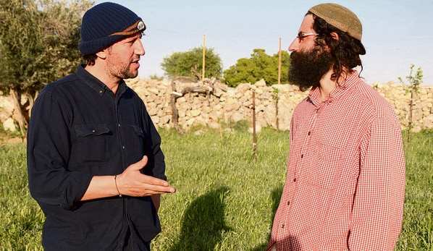
Shorashim- Judor is a local intiative of Palestinians and Israelis in the areas of Bethlehem-Gush Etzion-Hebron. The project was founded after a meeting between the students of Rabbi Menachem Fruman and local Palestinian leaders and has developed into a formal project after many visits of Pre-military Academies, delegations of journalists and politicians, interfaith groups, and groups of everyday civilians from throughout Israel. This initiative challenges local residents to take responsibility for the conflict - on personal, community, religious, and national levels, and espesiaaly challenge the attitude of despair towards the situation and the statement that "there is no peace partner".

14. RABBI FRUMANS LEGACY
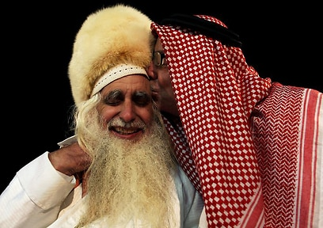
Rabbi Menachem Froman (1945-2013), was an Israeli Orthodox Rabbi and peacemaker and negotiator with close ties to Palestinian religious leaders. He was a founding member of Gush Emunim and served as a chief rabbi of Tekoa sattelment in the West Bank. He was well known for promoting and leading interfaith dialogue between Jews and Arabs, focusing on using religion as a tool for recognizing the humanity and dignity of all people. He is among the key philosophers of the one state-2 nation solution.

15. SHIVI FRUMAN
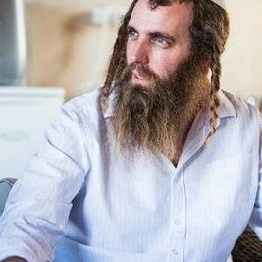
An Israeli human rights activist and cofounder of "Just Beyond Our Borders," a crowd-funding initiative that provides humanitarian aid for children in Syria. The son of Rabbi Froman, and a continuer of his legacy. Him and his views, became known in Israel especially after his pregnant wife was injured in a Palestinian terror attack in 2016.

