Kol Ami- Shabbat Schedulle
Friday
11:00-16:00 CLEANING
- Cleaning Rooms
- Cleaning Mo'adon
- Cleaning Classroom
- Bringing supply to classroom: toilet paper, cutleries, plates, food from catering
- Setting classroom into dining erea
16:30-17:30 Kol Ami greets Shabbat
17:30 Kabalat Shabbat
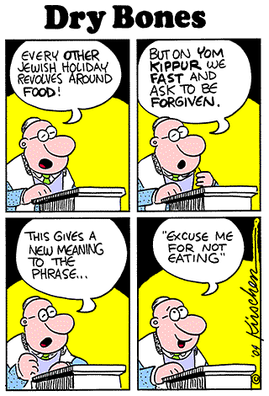
19:00 Yummy Shabbat Dinner
21:00 The best Oneg Shabbat EVER!

Shabbat
- Preparing Kidush
10:30 Kidush
- Cleaning classroom
- Warming up lunch food
11:30-12:30 Yarden's lesson
- Setting classroom into dining erea
12:30 Its time to feast! Lunch!
- Cleaning lunch, setting classroom
BREAK
17:00 Shalishides (Don’t know what is it?! Come and find out!)
- Preparing dinner
- Setting classroom into dining erea
18:30 Really? We're eating again?! Dinner
- Cleaning dinner
- Setting classroom
Havdalah

